Achadunan Cottage

i. General

This is Achadunan Cottage which is a Dorran building, built at the end of the 1950s or very early 1960s by the estate. A Dorran building is a bungalow, basically a kit house formed of prefabricated concrete panels, bolted together and harled on the outside. There are at least two Dorran buildings on the estate, the other one is at Ardno. Dorrans represent the early phase of kit houses, built with brick foundations and consisting of 50mm thick concrete panels, 2ft wide. The walls have an internal timber framework and a 6mm polystyrene insulation. The chimney was pre-cast built of 4” interlocking blocks.

Achandunan Cottage was built in 1966, and must have been John Macdonald’s first job. It is located upon the first area of rising ground above the strath within Glen Fyne, with a west facing view overlooking the river.

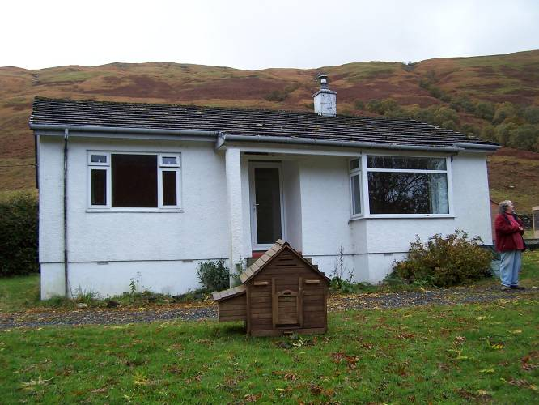
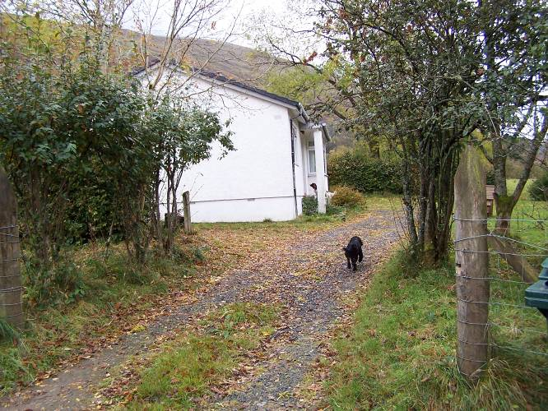
Figure 8 and 9 – Achandunan Cottage: Access from Glenfyne road and N gable (left); main elevation to W with entrance arrangement and bay window of living room to N (right),.

The cottage is accessed by a small drive off the Glen Fyne road which sweeps in from the north-west and runs along its west side. The cottage itself is located on rising but relatively level ground above the main road. The plot is bounded by a small gulley to the south containing a very small burn and to the north by a beech hedge and a further area of ground that runs up to one of the early estate enclosure walls of dry stone and very substantially construction.

ii. External elevations

The principal elevation faces west and the structure is broadly of three bays and single storey under a very low double pitched roof. The roof consists of cement tiles rising to a ridge with a small chimney offset to the south rising from this ridge. The external surfaces are finished at the lower bases in flat render rising up to ventilation bricks at floor level, above which there is a slight projection. The upper walling is all of cement harl.

The principal entrance is in the centre of the west side. This is reached by a short flight of five pre-cast concrete steps rising up to a tiled entrance area; the entrance itself recessed. There is a slight extension of the eaves on this side, forming a small open porch that is supported to the north-west by a single rendered pier. To the south-west the eaves’ extension spans over a bay window within the drawing room. Elsewhere the eaves are slightly overhanging and they are simply detailed with boarded fascias.

The north gable wall presents no window openings and is simply rendered. The rear wall contains four window openings, two large ones to the north and a similar large one at the south end with one smaller one on its north side.

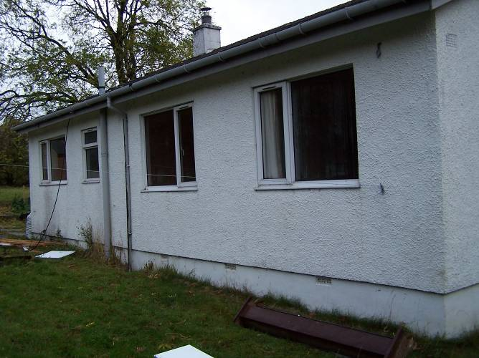
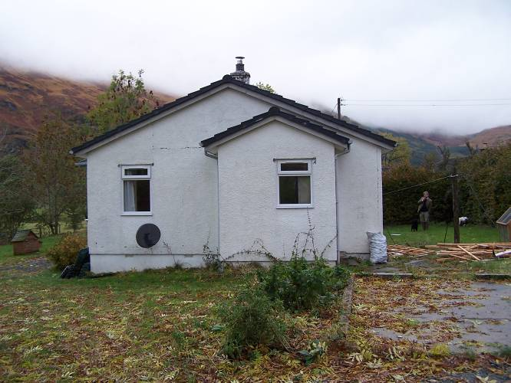
Figure 10 and 11 – Achandunan Cottage: S elevation with side porch (left), E elevation to rear (right).

Against the south gable wall there is a small porch structure, slightly offset to the east. This has an external entrance on its east side, accessed by means of two pre-cast concrete steps. The porch is coeval with the rest of the building and is lit by a single window in its south side. The south gable wall of the house proper contains one window, offset to the west.

iii. Interior

The principal entrance gives access into a narrow hall which runs into the interior and then branches to north and south into a passage from which all rooms are accessed. At the south end of the access corridor which runs north/south through the building is a slight dogleg at the east of the kitchen and at the angle of the dog's leg there is a press cupboard. All interior walls are stud lined and stud framed with plasterboard over.
The doors throughout are of ply, unornamented with simple architraves with rounded angles. The skirtings are similarly detailed with a slightly rounded top and a very simple applied cornice, detailed with a very slight cyma profile. The door furniture is of brushed stainless steel. The door within the principal entrance has been replaced with a double glazed PVC unit.

All the windows were also replaced with PVC in 2009, otherwise the structure is remarkably of one period and retains its overall character very well.

To the south-west is the principal living room, this with its principal features the broad projecting bay window arrangement to the west and in the centre of the east wall a fireplace which had had a tiled surround and a Baxi fire within, but this is now removed and replaced with a modern multifuel unit.

To the south-east is the kitchen which has been modernised and the kitchen units replaced. From within the kitchen is the access to the exterior rear entrance and porch in the south wall.

There is a bathroom in the centre south part of the east side. Again, the existing fittings, bath, toilet etc. are replacements of relatively recent date.

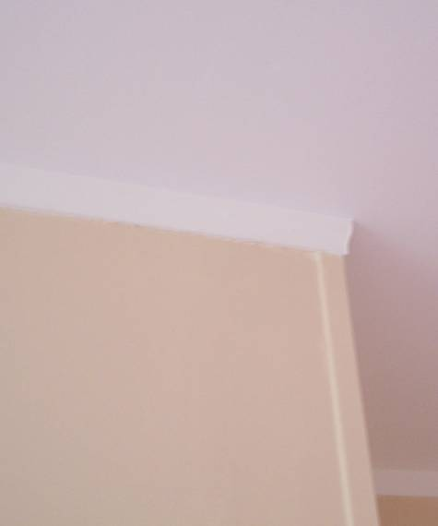
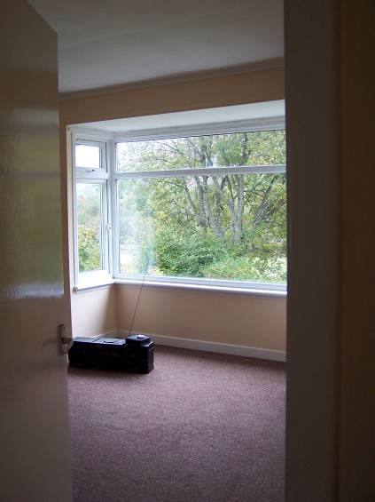 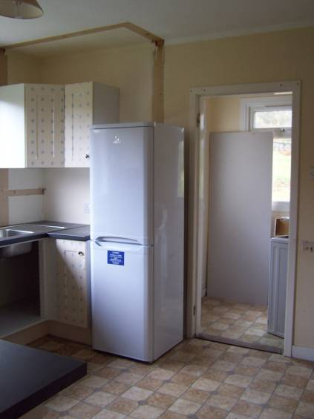 Figure 12, 13 and 14 – Achandunan Cottage: view into living room and bay window (left), kitchen with side porch (centre), detail of cyma cornice profile (right).

Continuing north on the east side there is a small box bedroom with broad window to the east. Within this room is a single press cupboard accessed by a door in the centre of the north wall.

To the north-east there is a further bedroom. This is with a double press cupboard arrangement, this time in the south wall, sharing the space with the press cupboard in the room next door.

To the north-west is the principal bedroom with a broad window out to the west. Within this room, in the south wall are two press cupboard doors.

